ELEVATE LABS TASK 11

Phishing Attack Simulation & Detection

Student Name: Sai pavani
University: Aditya University
Domain: Cybersecurity
Duration: 1st January 2026 to 30th April 2026

Understand phishing attacks
Phishing attacks are a form of social engineering in which attackers trick users into revealing sensitive information by pretending to be a trusted source such as a bank, organization, or service provider. These attacks are commonly carried out through emails, messages, phone calls, or fake websites that create a sense of urgency or fear, prompting users to act quickly without verification. Phishing does not rely on technical hacking alone; instead, it exploits human trust and behavior, making it one of the most effective and widely used cyberattacks.

Types:-
Email phishing is the most common type, where fraudulent emails contain malicious links or attachments

Spear phishing targets specific individuals or organizations using personalized information

Whaling is a high-level spear phishing attack aimed at executives or senior officials.

Smishing uses SMS or messaging apps to send fake alerts or links

vishing involves phone calls where attackers pose as bank or support staff

Clone phishing copies a legitimate email but replaces the original link or attachment with a malicious one.

Create fake email template
Creating a fake email template in GoPhish is done for security awareness training and phishing simulation, not for real attacks. The purpose is to help organizations understand how phishing emails look, how users react to them, and how to improve employee awareness. In a phishing
simulation, a realistic-looking email template is designed to test whether users can identify suspicious messages. These templates mimic common phishing characteristics such as urgent language, branding style, and call- to-action buttons, but are used only in controlled environments with prior authorization. The results help security teams measure risk, improve
training, and strengthen email security policies.

Step 1: Download GoPhish
Wget
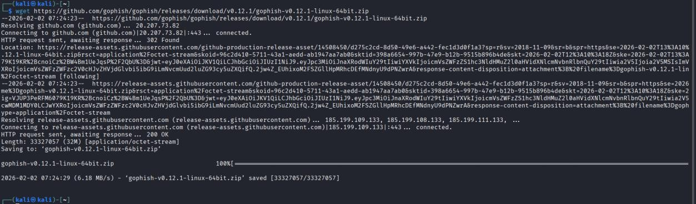
https://github.com/gophish/gophish/releases/download/v0.12.1/gophish- v0.12.1-linux-64bit.zip

Extract files:
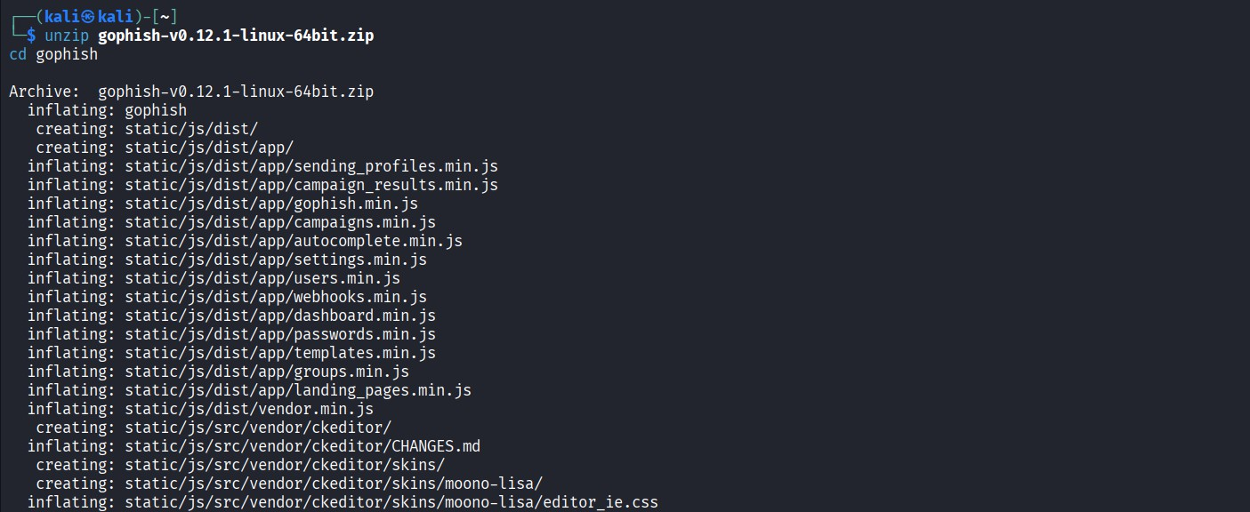
unzip gophish-v0.12.1-linux-64bit.zip cd gophish

Give execution permission:
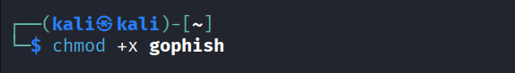
chmod +x gophish

Step 2: Start GoPhish Server
Run GoPhish:
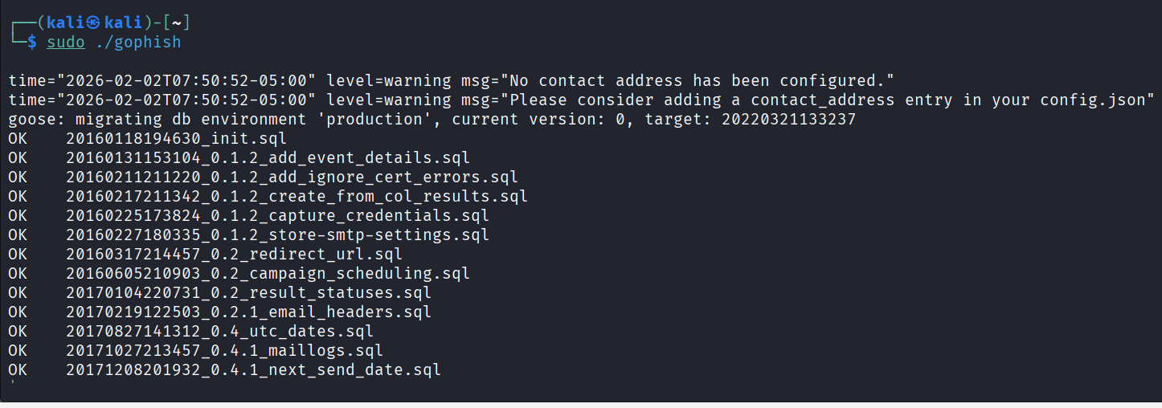
sudo ./gophish

Step 3: Access GoPhish Dashboard Open browser and go to: https://127.0.0.1:3333

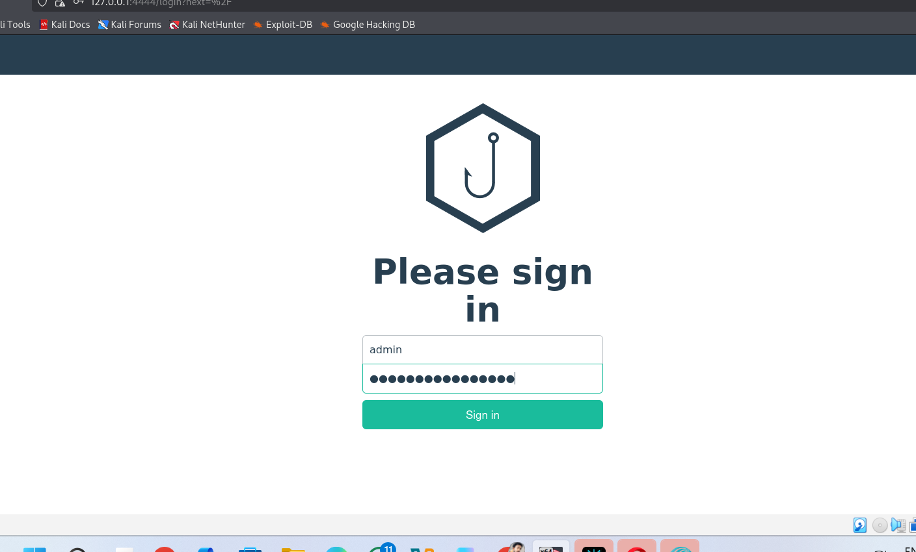
Step 4: Create Email Template
- Dashboard → Email Templates
- Click New Template
- Enter details:
  - Name: Security Awareness Email
  - Subject: Security Awareness Notification
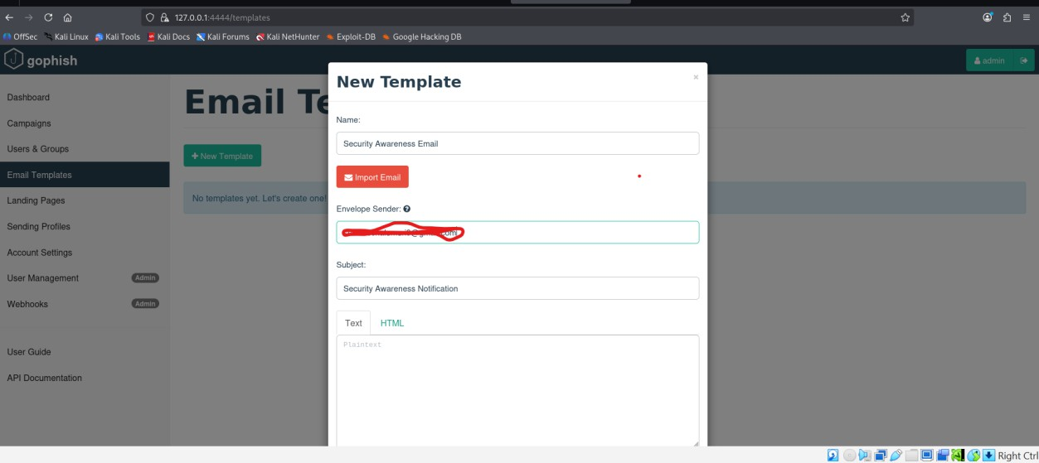
  - From: IT Security Team

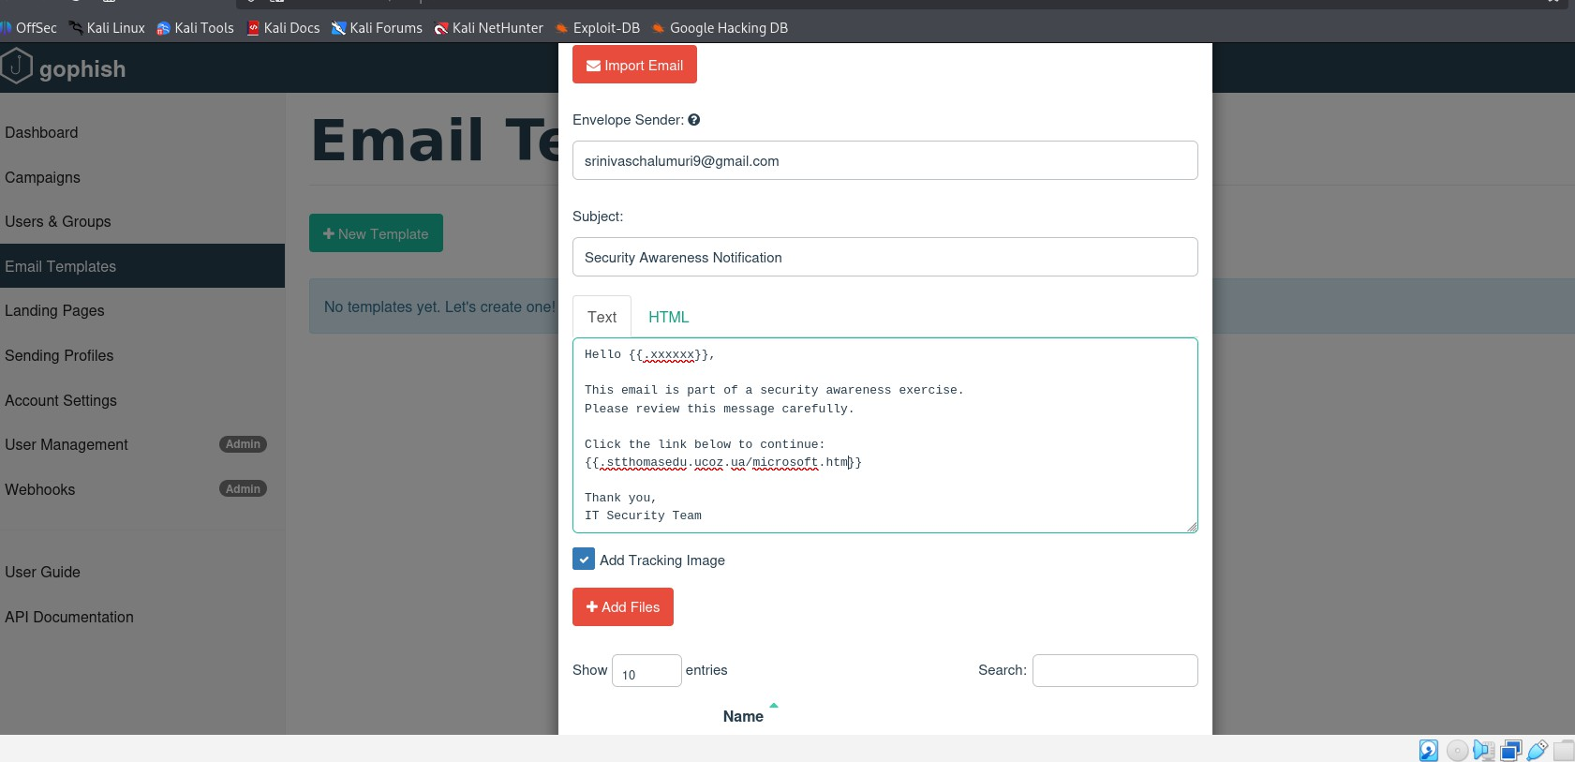
Step 5: Add Email Body (Training Purpose)

Step 6: Save Template
- Click Save Template
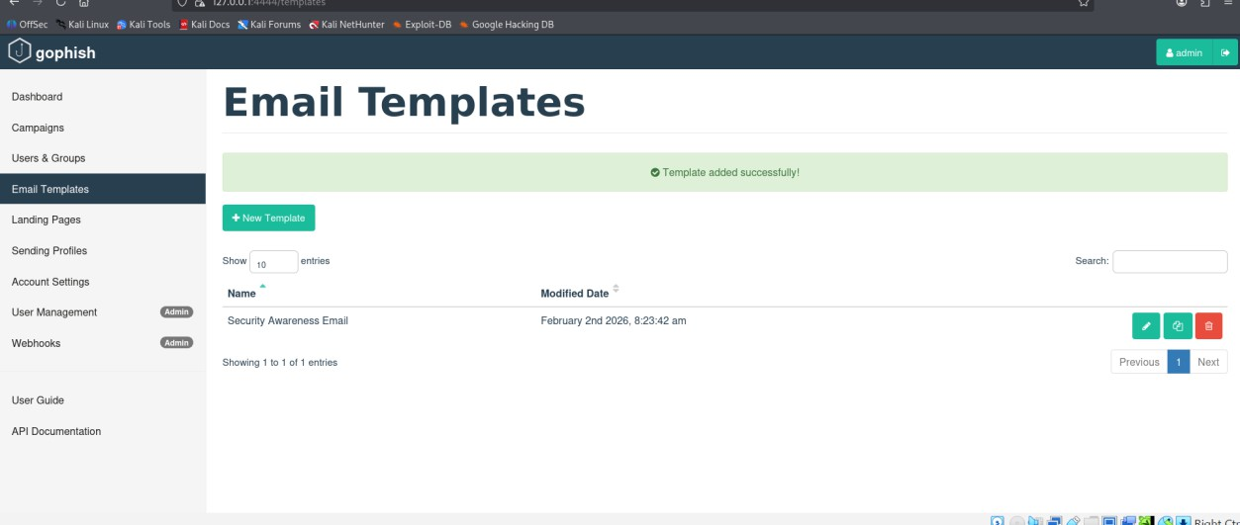
- Email template is successfully created

Setup Landing Page
A landing page in GoPhish is the web page that users are redirected to after clicking link in a phishing simulation email. In security awareness training, landing pages are used to educate users, record click behavior, and demonstrate how phishing attacks attempt to collect information.
Instead of stealing real credentials, an ethical landing page displays a warning or training message explaining that the user has clicked a simulated phishing link. Setting up a landing page helps organizations analyze user awareness, improve training programs, and reduce the risk of real phishing attacks.

Step 1: Open GoPhish Dashboard
  - Start GoPhish
  - Open browser
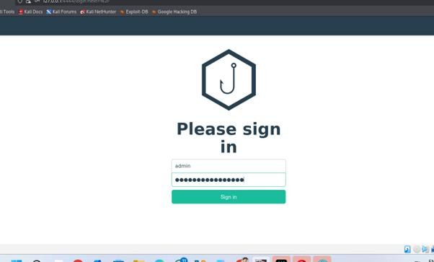
  - Go to:

Step 2: Navigate to Landing Pages
  - Dashboard → Landing Pages
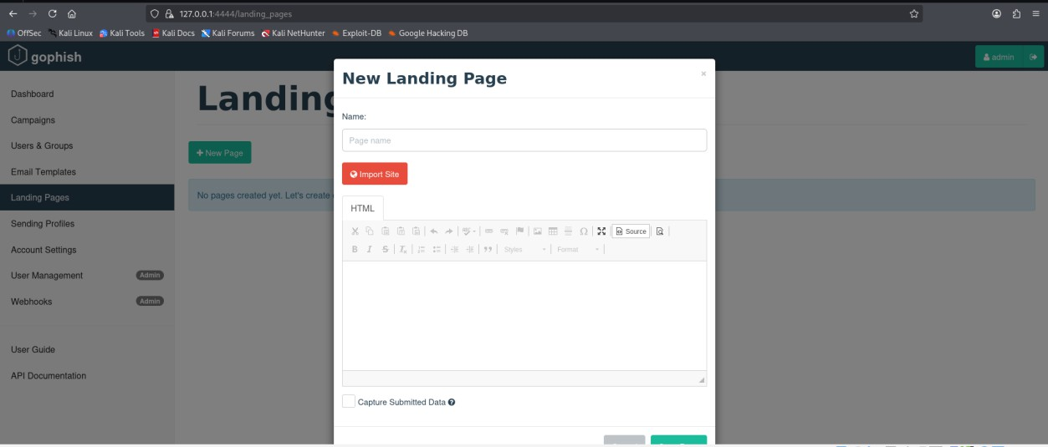
  - Click New Page

Step 3: Create Landing Page Details
Fill the following fields:
  - Name: Security Awareness Page
  - HTML Content:
  - 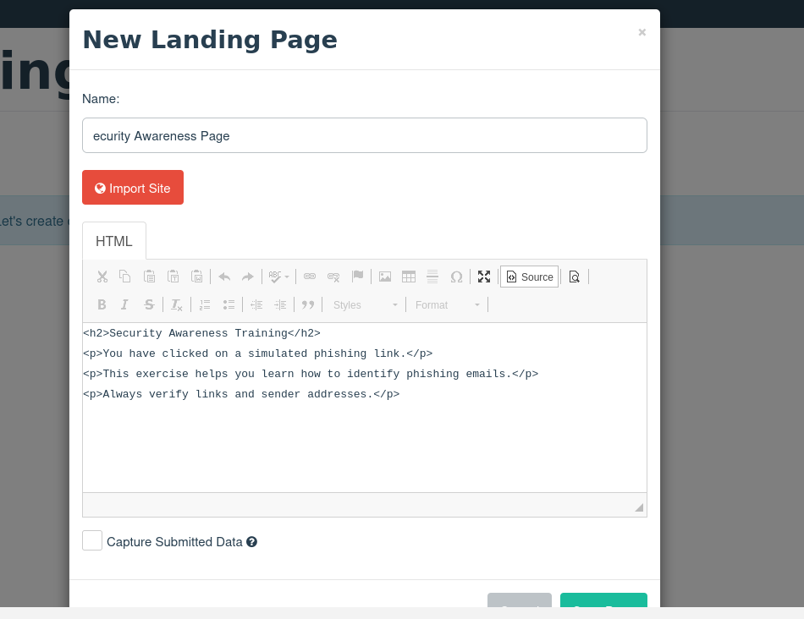

Step 4: Configure Page Settings
Enable / Disable options carefully:
  - Capture Submitted Data: OFF
  - Capture Passwords: OFF
  - Redirect to URL:

Step 5: Save Landing Page
  - Click Save Page
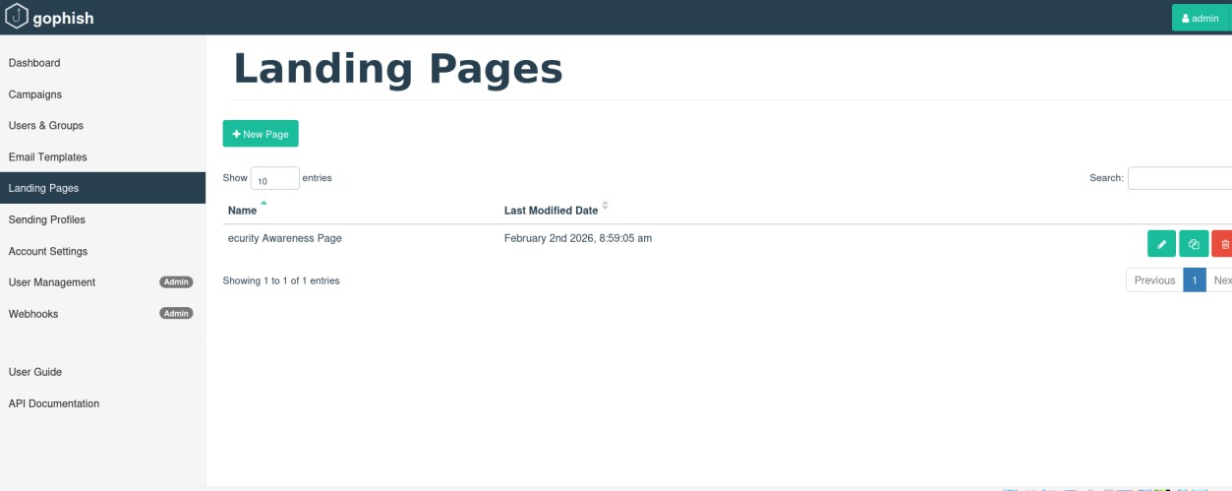
  - Landing page is now created successfully

Step 6: Link Landing Page to Email Template
  - Go to Email Templates
  - Edit your template
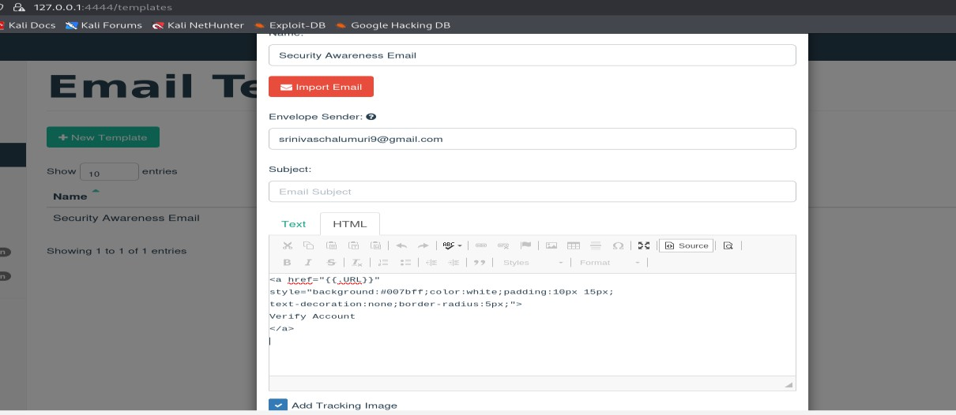
  - Use:

Send test phishing email
Sending a test phishing email in GoPhish is part of a controlled security awareness simulation. The purpose is to verify that the email template, landing page, and sending profile are correctly configured before launching a full campaign. Test emails help security teams ensure that links work properly, emails are delivered successfully, and tracking is enabled. This step reduces errors and ensures the phishing simulation is conducted safely, ethically, and with authorization.

Step 1: Create Sending Profile (If Not Created)
- GoPhish Dashboard → Sending Profiles
- Click New Profile
- Fill details:
  - Name: Test SMTP Profile
  - From: IT Security itsecurity@test.com
  - Host: smtp.gmail.com:587 (example)
  - Username: sender email
  - Password: app password
- Enable TLS
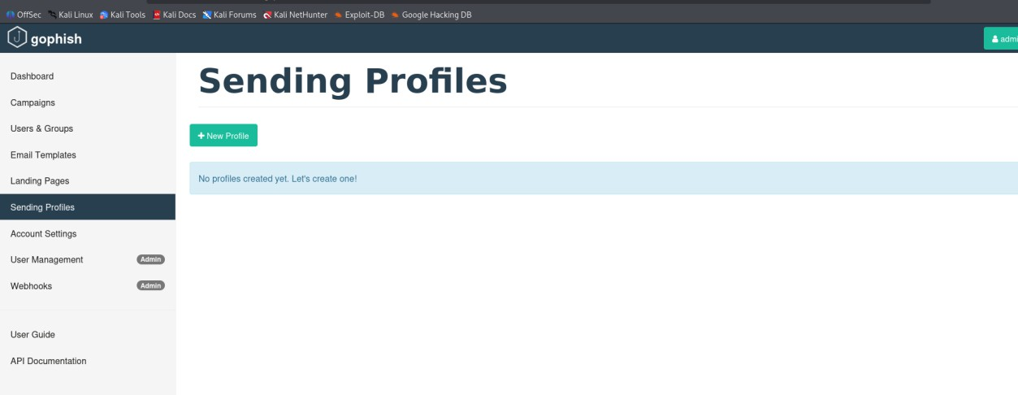
- Click Save Profile

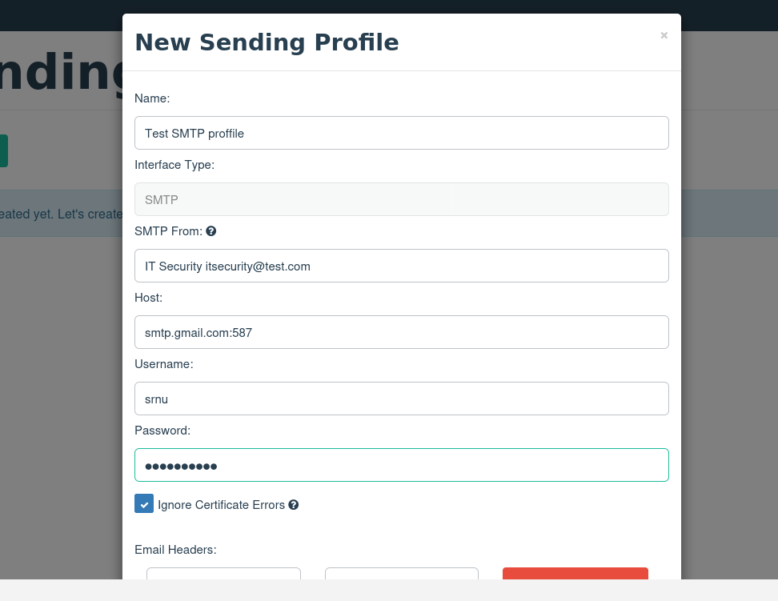
Track responses.
Tracking responses in GoPhish is used to monitor how users interact with a phishing awareness campaign. It helps security teams understand whether users open emails, click links, or submit data. By analyzing these responses, organizations can measure user
awareness, identify risky behavior, and improve security training. Response tracking in GoPhish provides real-time statistics and detailed reports for evaluating the effectiveness of phishing simulations.

Step 1: Open Campaign Dashboard
Open GoPhish dashboard Click on Campaigns
Select the running or completed campaign

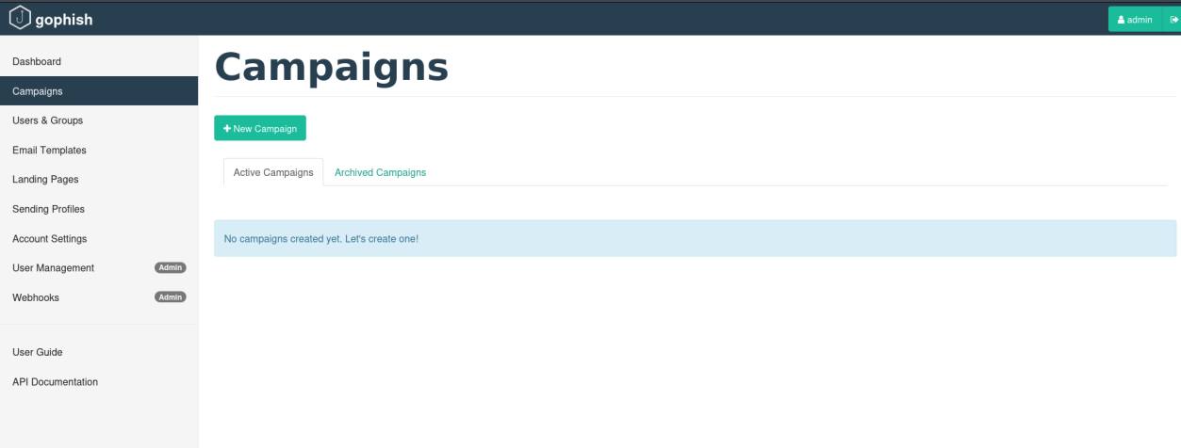
Step 2: View Campaign Statistics
On the campaign page, observe the following metrics: Emails Sent – total number of emails delivered
Emails Opened – number of users who opened the email Clicked Links – users who clicked the phishing link Submitted Data – users who entered information
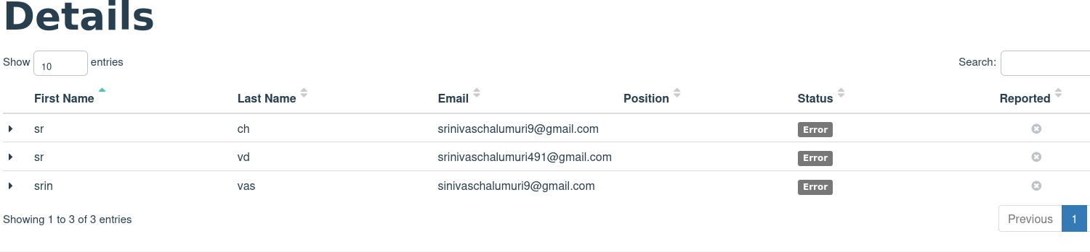
Reported – users who reported the email (if enabled)

Step 3: Timeline Analysis
View the timeline graph
Analyze when users interacted with the email Identify quick clicks indicating high risk

Step 5: Export Results
Click Export Results (CSV)
Save the report for documentation or lab record

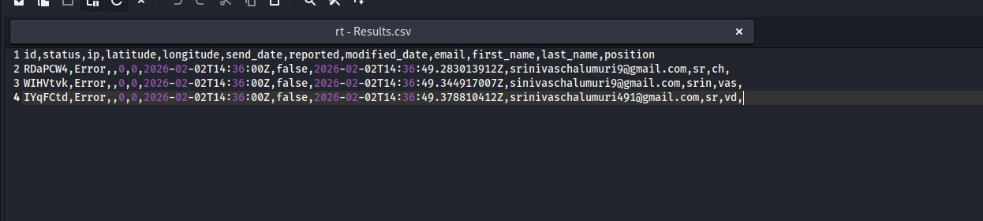
Identify Red Flags
Red flags in phishing emails are warning signs that indicate a message may be fraudulent or malicious. Identifying these red flags helps users avoid falling victim to phishing attacks. In GoPhish awareness
campaigns, red flags are intentionally included in email templates so users can learn how attackers manipulate trust, urgency, and curiosity. Recognizing red flags improves user awareness and reduces the success rate of real phishing attacks.

Learn Prevention
Phishing prevention refers to the methods and practices used to protect users and organizations from phishing attacks. Since phishing targets human behavior rather than system vulnerabilities, prevention focuses on user awareness, secure email practices, and technical controls. Learning prevention helps reduce the success rate of phishing attacks and
minimizes data breaches, financial loss, and identity theft.

Document Simulation

  - GoPhish is used for phishing awareness and simulation
  - Email template is created to simulate phishing emails
  - Landing page is set to capture user interaction safely
  - SMTP sending profile is configured for email delivery
  - User group is created with test email addresses
  - Campaign is created using template and landing page
  - Test phishing email is sent to users
  - User actions like open and click are tracked
  - Phishing red flags are identified from the email
  - Results are analyzed to improve user awareness

